**Assignment**

Task1:- Set up unity project &confrigure the vr Envirioment

* On the unity engine.
* Set up vr environment.

-Go to file>build settings

-select the target platform-android for oculus

-Go to player settings and under XR settings enable virtual reality

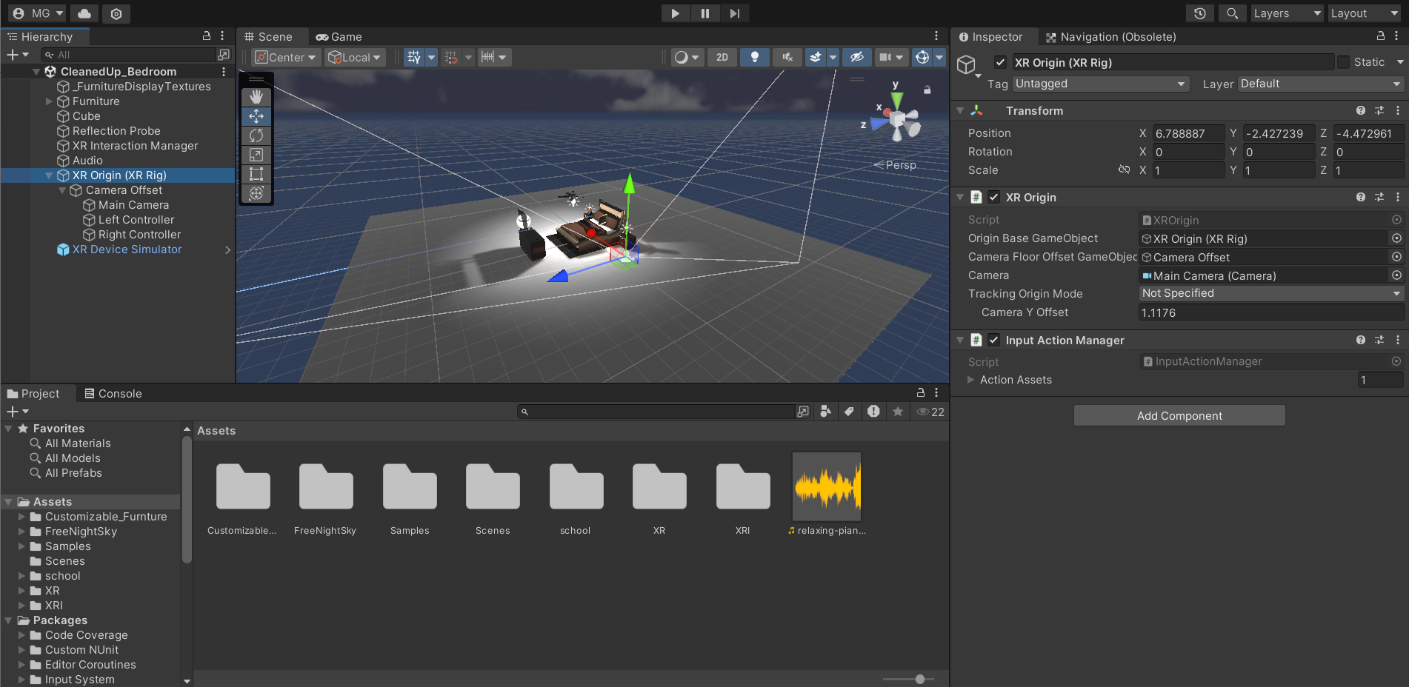

Task2:- Create the ground plane

-First we go to hierarchy panal right click on that and add 3D object and add plane.

-It will help us to give ground to our assests.

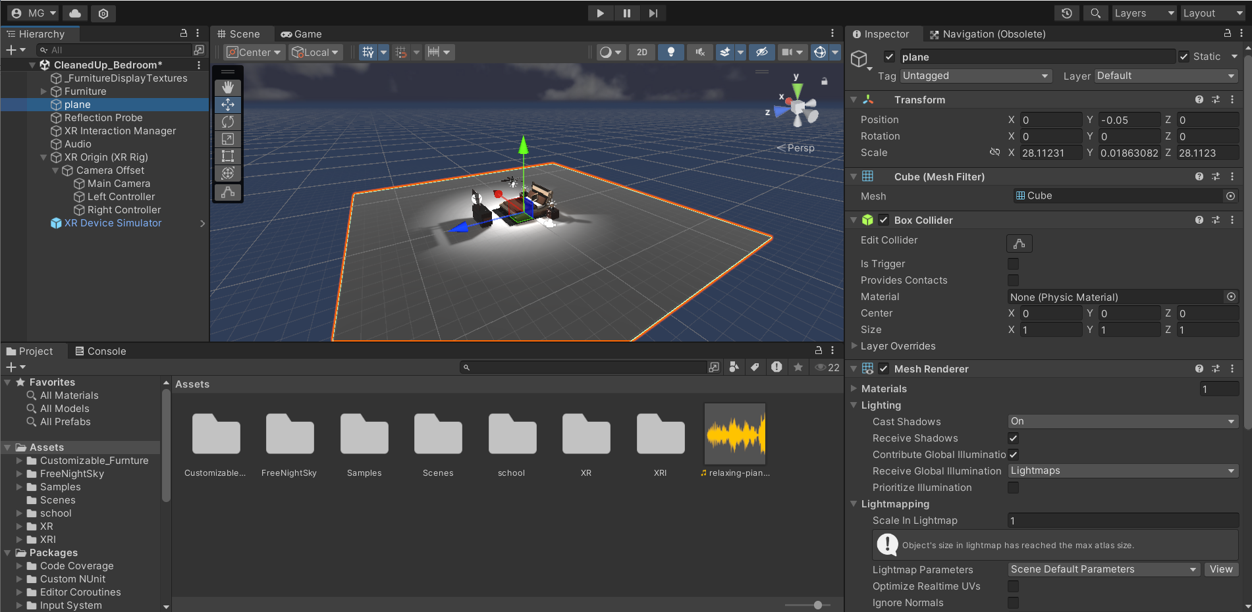

Task3:- add a skybox asset.

-download a sky box assest from the unity asset center.

-open it to unity download and import the asset .

-then drag the assets to the hierarchy panal.

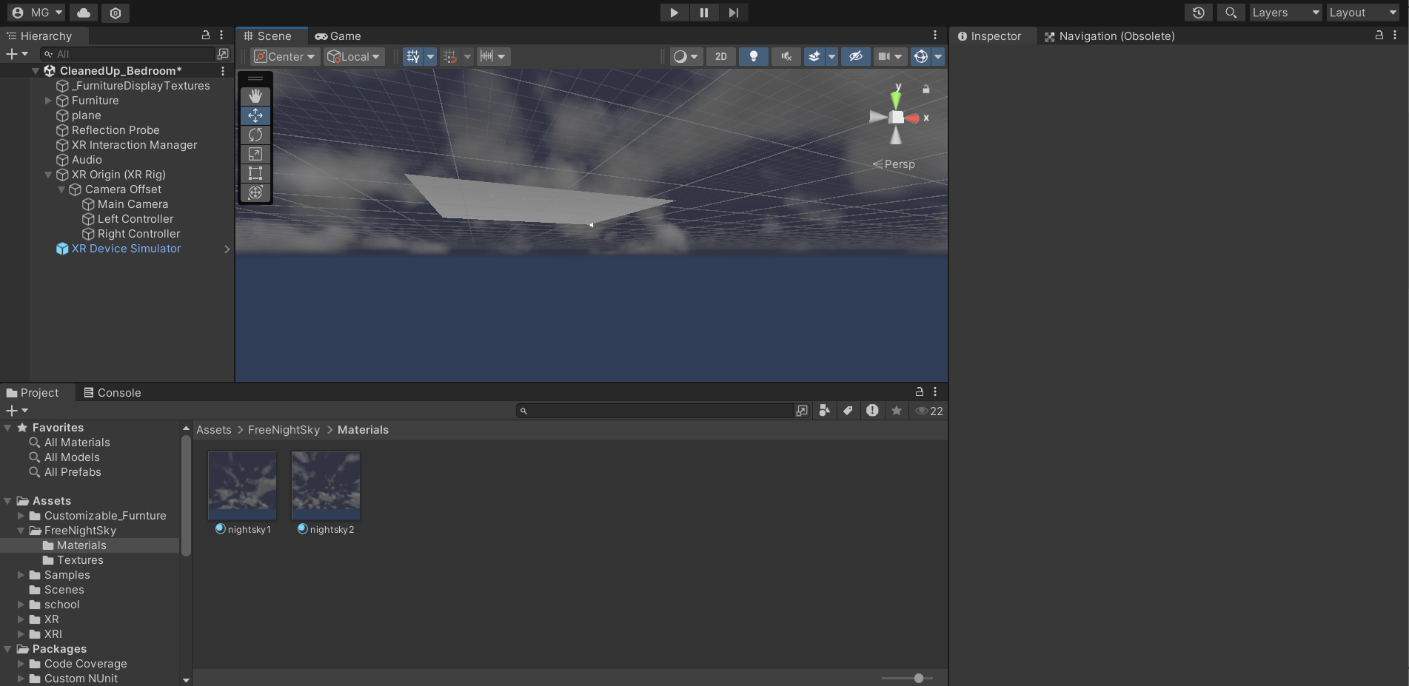

Task4:- Add environment objects

-First download the assets for the same site (unity.assets).

-Import from the pacakage manager

-Go to window>pacakage manager>MyAssets>import the assets.

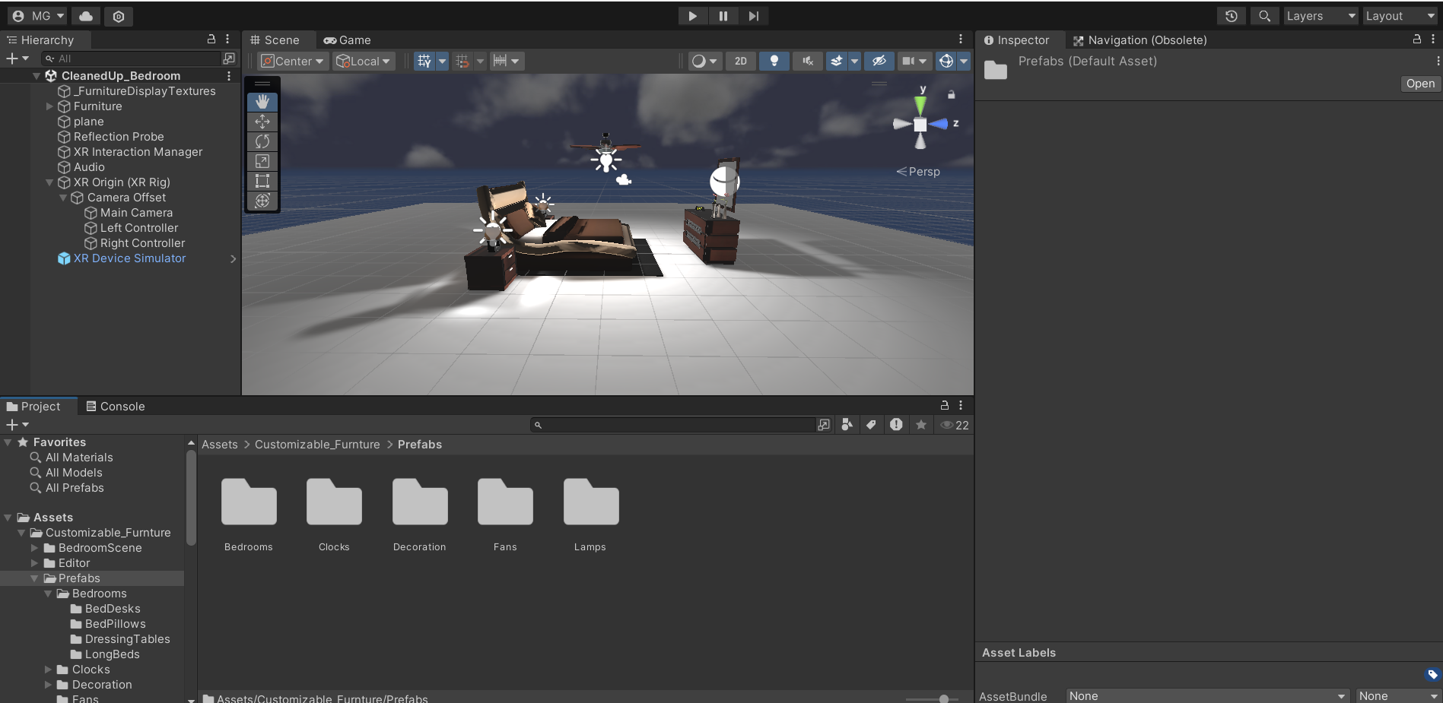

Task5:-Configure Lighting and shadows

-Go to window > Rendering > Lighting and adjust the lights on the assets.

-In the light panal Enable the shadow for objects by selecting the light and turning on Cast Shadows in its properties.

-Adjust show resolution and distance in lighting stings to optimize for VR performance.

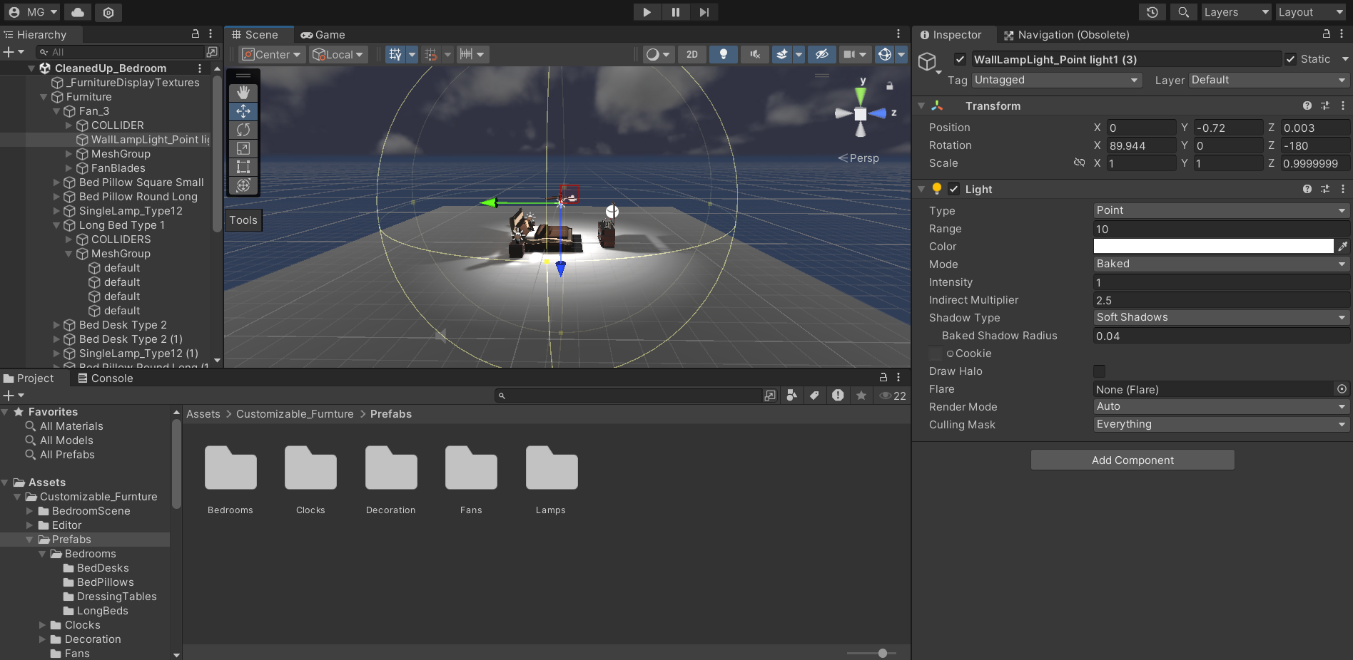

Task6:-Audio clip.

-download the audio clip in mp3

-In unity go in the hierarchy panal right click on it and select the create empty and name it as audio.

-import the audio in the assets folder down the hierarchy.

-select the audio and go to the right panal and in that go to add component and add audio source and In that drag the audio to the first bar in the audio cource.

